H.T No
Regulations:
A20

Sreenidhi Institute of Science and Technology
(An Autonomous Institution)
Code No:8HC09 Date: 31-Jan-2024 (AN)

B.Tech I-Year I- Semester External Examination, Jan/Feb-2024 (Supplementary)
MATRIX METHODS AND CALCULAS(CIVIL,EEE,ME and ECE)

Time: 3 Hours Max.Marks:70

Note: a) No additional answer sheets will be provided.
b) All sub-parts of a question must be answered at one place only, otherwise it will not be valued.
c) Missing data can be assumed suitably.
Bloom's Cognitive Levels of Learning (BCLL)

Remember | L1 | Apply | L3 | Evaluate | L5
Understand | L2 | Analyze | L4 | Create | L6

Part - A Max.Marks:20

Answer all QUESTIONS.

 |  | BCLL | CO(s) | Marks
1 | Define rank of a matrix | L2 | CO1 | [2M]
2 | Find the eigen values of the matrix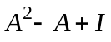, where 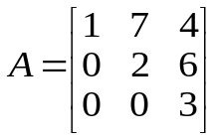 | L2 | CO2 | [2M]
3 | Find the value of the Fourier coefficient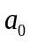for the function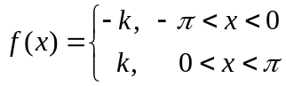 | L2 | CO3 | [2M]
4 | Find the value of Rolle’s theorem for the function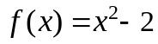 in 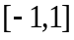 | L2 | CO4 | [2M]
5 | Evaluate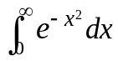 | L2 | CO5 | [2M]
6 | Find the stationary points of 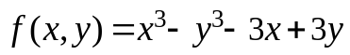 | L2 | CO6 | [2M]
7 | Define symmetric and skew-symmetric matrices with examples | L2 | CO | [2M]
8 | Obain Maclaurin’s series expansion of 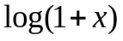 | L2 | CO | [2M]
9 | Find the value of 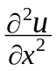 at 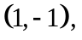where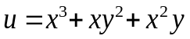 | L2 | CO | [2M]
10 | Evaluate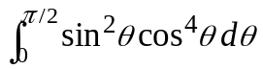using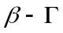functions | L2 | CO | [2M]

Part – B Max.Marks:50
ANSWER ANY FIVE QUESTIONS. EACH QUESTION CARRIES 10 MARKS.

 |  |  | BCLL | CO(s) | Marks
11. | a) | Reduce the matrix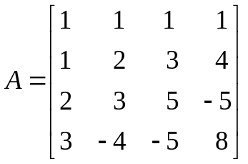into echelon form and hence find its rank | L3 | CO1 | [5M]
 | b) | Solve the following system of equations by using Gauss elimination method: | L3 | CO1 | [5M]
12. |  | Find the Eigen values and corresponding eigen vectors of the matrix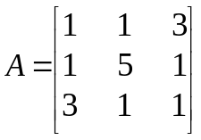 | L3 | CO2 | [10M]
13. |  | Expand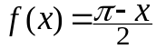 as a Fourier series in Hence deduce that 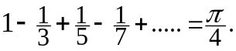 | L3 | CO3 | [10M]
14. |  | If 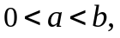 prove that 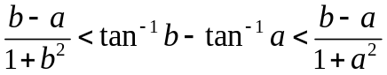using Lagrange’s mean value theorem. Hence deduce that 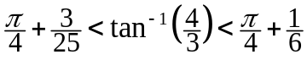 | L3 | CO4 | [10M]
15. | a) | Show that 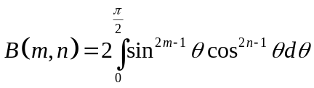 | L3 | CO5 | [5M]
 | b) | Find the volume of the portion of the sphere 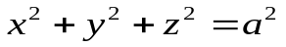lying inside the cylinder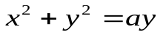. | L3 | CO5 | [5M]
16. | a) | Find the directional derivative of 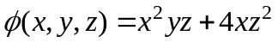at the point 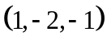 in the direction of the vector 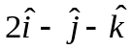 | L3 | CO6 | [5M]
 | b) | Show that the functions 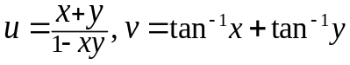 are functionally dependent and find the relation between them. | L3 | CO6 | [5M]
17. | a) | Test for consistency and solve | L3 | CO1 | [4M]
 | b) | Find the inverse of the matrix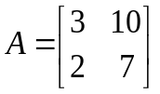 by using Cayley-Hamilton theorem | L3 | CO2 | [3M]
 | c) | Express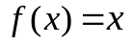as a half-range Fourier cosine series in 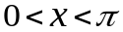 | L3 | CO3 | [3M]
18. | a) | Verify Cauchy’s mean value theorem for the functions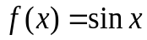and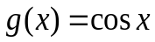in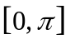 | L3 | CO4 | [4M]
 | b) | Evaluate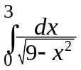 | L3 | CO5 | [3M]
 | c) | If 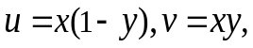evaluate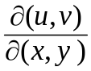 | L3 | CO6 | [3M]
-- 00 -- 00 –

